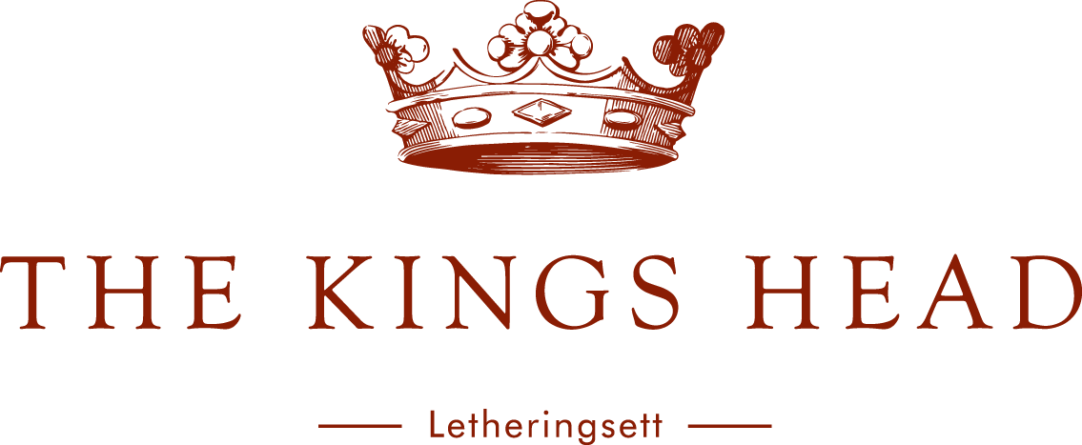

Norfolk Restaurant Week Menu 2025

3rd to 7th & 10th to 14th November (not weekend)

2 courses £27
3 courses £33

Starters
Homemade Soup, Krusty Loaf Sourdough
Salt Fish Brandade, Capers, Lemon & Sea Herbs
Crayfish Cocktail, Shredded Gem, Marie Rose
Crispy Pork Belly, Burnt Apple, Granny Smith

Mains
Minute Steak Schnitzel, Sauerkraut, Russian Dressing, Fries
Norfolk Bacon Chop, Fried Egg, Chunky Chips
Pan Fried Sea Bream, Romesco, New Potatoes, Crispy Seaweed
Goats’ Cheese Soufflé, Cheese Cream, Mixed Blakeney Leaf

Puddings
Honey Roasted Fig, Crème Fraiche, Shortbread
Peach Crumble, Vanilla Ice Cream
Mrs Temple’s Binham Blue, Artisan Crackers, Chutney
A selection of Dann’s Luxury Norfolk Ice Cream & Sorbet

