Welcome Back

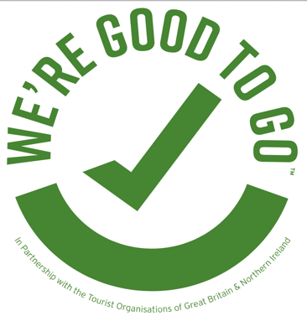

In order to make sure we are Covid secure, and to help you understand the part you play in helping us maintain a safe place for everyone, we have the following house rules:

Table Reservations
Please call or book online in advance but if you’re already here please check with the host team to see if we have any tables available.

One way system
Please follow floor markings and keep 2m apart from others outside of your party. We have control measures clearly signed where 2m is not possible, please observe these

Families Welcome
We welcome children please make sure that they are with you at all times

Table/Lawn Service
Please stay seated at your table as much as possible, we will do everything we can to get you what you need so you can relax in comfort. If we are not doing table service for orders, place your orders at the appointed area

Card Payment only
We are only accepting card payments at this time.

Wash / Sanitize Your Hands
Hand sanitizers are available throughout the building for you to regularly sanitize your hands

Cleanliness Policy
There are extra cleaning standards in place including sanitizing of touchpoints, tables and chairs. Please be assured that our staff are taking extra hygiene measures to help make the service more Covid secure

